# Digital Verification using SV and UVM

# Assignment-5

# Name: Fares Khalaf Sultan

# Part#1:

# UVM Environment:

# 

# Do file:

# Results:

# Part#2: Driving the interface:

# UVM Environment:

# 

# 

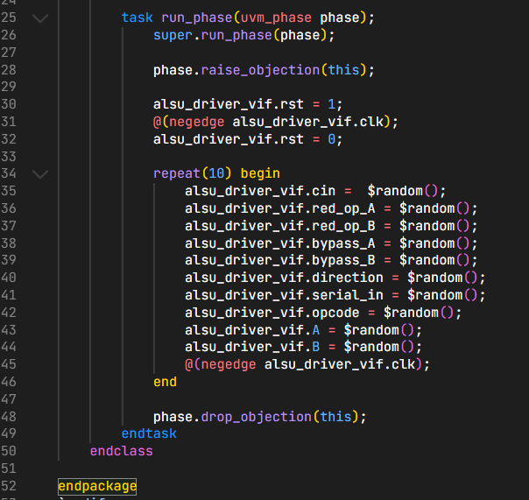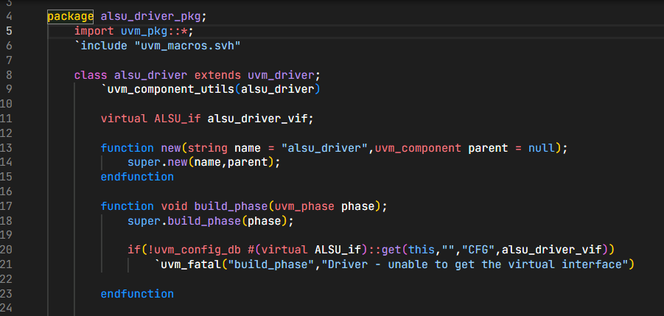

# Results:

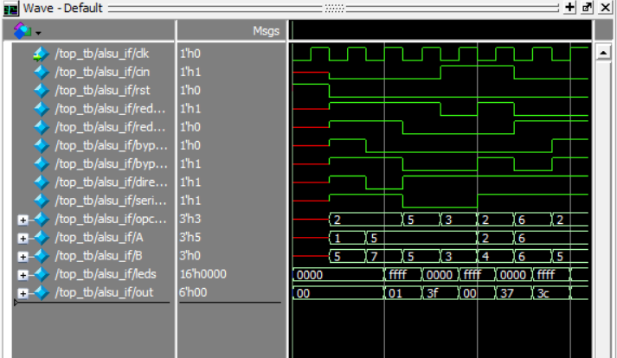

# Part#3: config object:

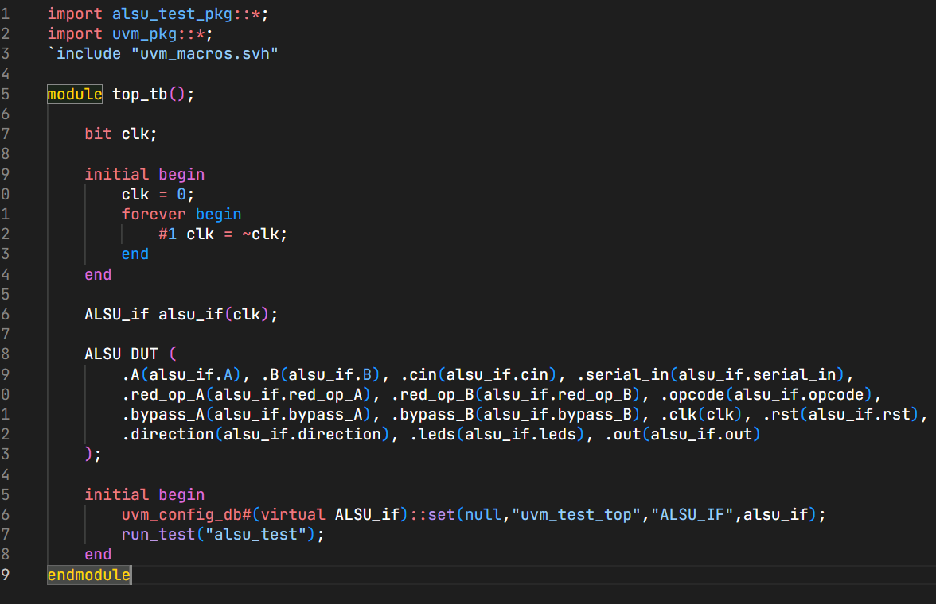

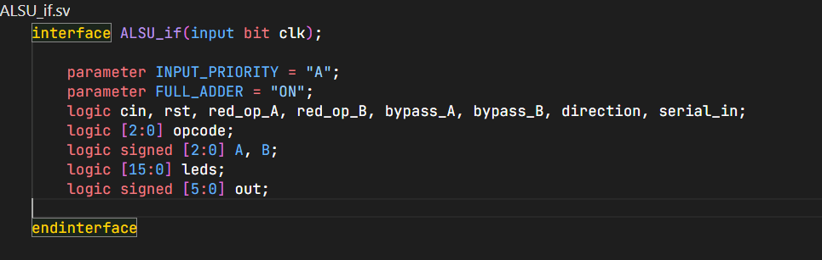

* 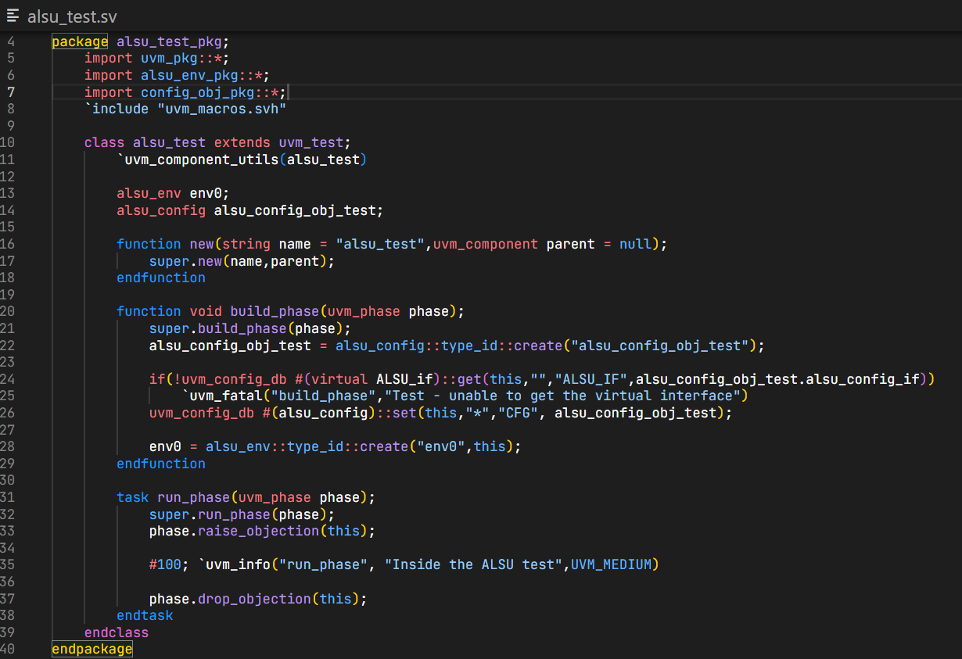**Test:**
* **Config object:**

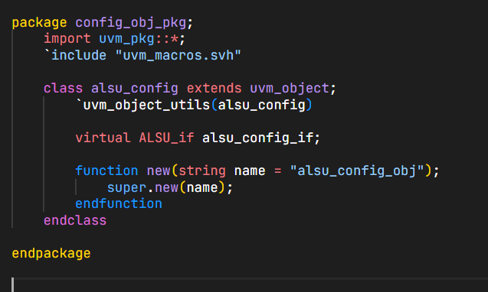

* 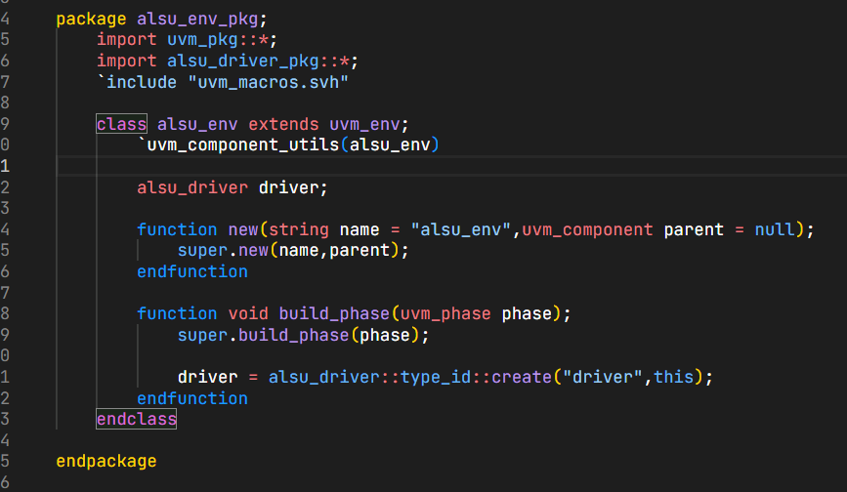**Env:**
* 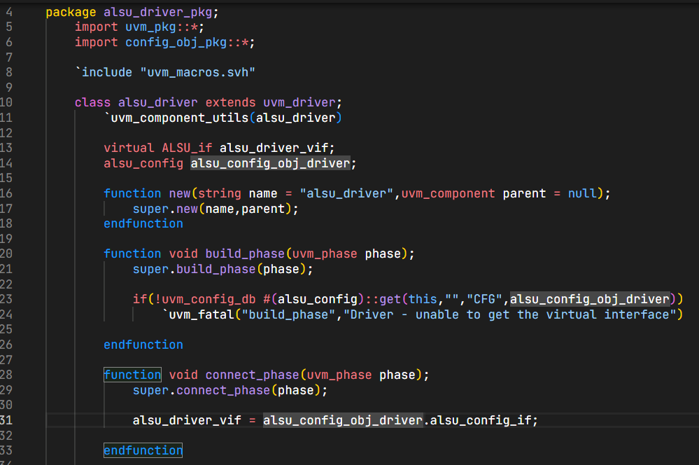**Driver:**

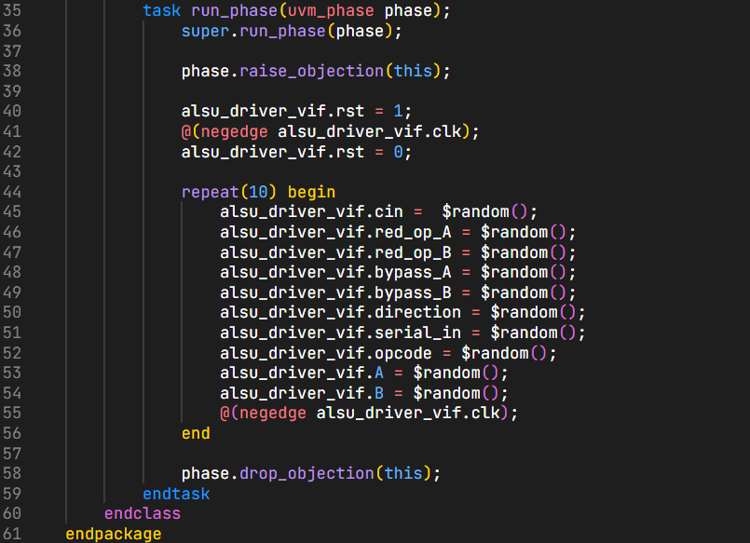

# Result:

Waveform:

# 